Apollo 8:
Earth Rise
By: Larry Harrison
“Exploration really is the essence of the human spirt, and to pause, to falter, to turn our back on the quest for knowledge, is to perish.”
Col. Frank Borman (Commander of Apollo 8)
At 7:51 A.M. Eastern Standard time on December 21, 1968, five F-1 rockets successfully ignited and began to burn a mixture of RP-1 (rocket fuel) and Liquid oxygen (LOX) at the rate of nearly 20 tons per second! The mighty Saturn V, measuring an impressive 363 feet from tip to tail, slowly rose from launch pad LC-39A (located at Kennedy Launch Complex, Florida). Producing 7,500,000 pounds of thrust, the majestic monster successfully cleared the launch tower and thus began the mission of Apollo 8, first human crewed mission to the Moon.
The crew of Apollo 8 consisted of two space veterans, Col. Frank Borman (Commander) and Captain James Lovell (Command Module Pilot (CMP)), and rookie astronaut Major William Anders (Lunar Module Pilot (LMP)). The primary mission objective for the astronauts was to successfully traverse to the Moon, achieve a circular orbit around the Moon and then safely return to Earth.
The objective sounded simple, especially for mathematicians, rocket scientists, aerospace engineers, and stellar navigators; however, one must remember that 23 months prior to the launch of this mission, three astronauts lost their lives in a horrific accident during a testing of the command module’s “plugs out” capabilities (testing of internal power supplies). Furthermore, Apollo 8 carried the first crew to experience the mightiness of the Saturn V rocket system (Apollo 7 employed the Saturn 1B). So, the crew of Apollo 8 had a new rocket, a new objective, a new destination beyond low Earth orbit, and yet shared the same concerns as every astronaut to ever strap into the “couches” of a spacecraft. Their faith in the thousands of engineers, mathematicians, machinists, assemblers, technicians, and spacesuit seamstresses was unparalleled!
The crew’s faith was well warranted, as the first and second stages of the Saturn V rocket performed as expected, placing Apollo 8 in a low Earth orbit. Two orbits of Earth and at 02:50 elapsed mission time, the command for the translunar insertion (TLI) burn was initiated, thus beginning Apollo 8’s long journey to the Moon. With the third stage rocket’s successful burn, Borman, Lovell, and Anders were now further from Earth than any human had ever traveled.
Throughout their journey toward the Moon, several course correction burns were scheduled in the flight plan, however due to the exactness of the TLI burn and Lovell’s extreme navigation skills, most of the mid-course correction burns were cancelled. Apollo 8 was enjoying a safe and accurate ride toward their destination. Yet, one issue arose around the 18-hour mark of the outward-bound trip that may have resulted in an early mission scrub-Commander Frank Borman began vomiting and battling diarrhea.
Borman, down playing his sudden illness, was unwilling to discuss his health with mission control in fear of them calling a scrub to the remainder of the mission. However, Jim Lovell and Bill Anders “secretly” contacted mission control concerning their commander’s health, and mission control surgeons “privately” consulted with Borman. After the consultation with ground control, the decision to carry on was made, and Borman’s health slowly return to normal.
LOI (Lunar Orbit Insertion) burn was to take place at 69:08 elapsed mission time and the burn would be initiated while the Apollo 8 spacecraft was on the far side of the Moon. This critical burn, if successful, would place Apollo 8 an elliptical orbit around the Moon. However, once on the far side of Moon, no radio transmissions between the crew and mission control would be possible. Therefore, after an excruciating 40 minutes, mission controllers were quite relieved to hear the voice of Jim Lovel through the static in their earpieces.
With a successful LOI burn, the crew of Apollo 8 became the first humans to ever “fall” toward another celestial body! They were further from Earth than any humans had ever traveled, and with a slight delta V burn (to circularize their orbit), became the first humans to be within 59.7 miles of the lunar surface! Now, they just needed to make ten, two-hour orbits while taking as many photographs of the lunar surface as possible, complete a few scientific experiments, and perform a live Christmas Eve televised transmission for the folks back on Earth before they exited their lunar orbit.
On Christmas Eve 1968, the crew of Apollo 8 transmitted a live television broadcast in which they read from the Book of Genesis. NASA states that the broadcast was viewed by millions around the world, and is only surpassed by Neil Armstrong’s first steps on the Moon as NASA’s most widely viewed televised broadcast! However, as moving as the broadcast was to millions, it may pale in comparison to the image captured by Bill Anders during the fourth orbit of the Moon. The iconic image “Earth Rise”, is perhaps one of the most prolific images ever captured on film (see photograph below):
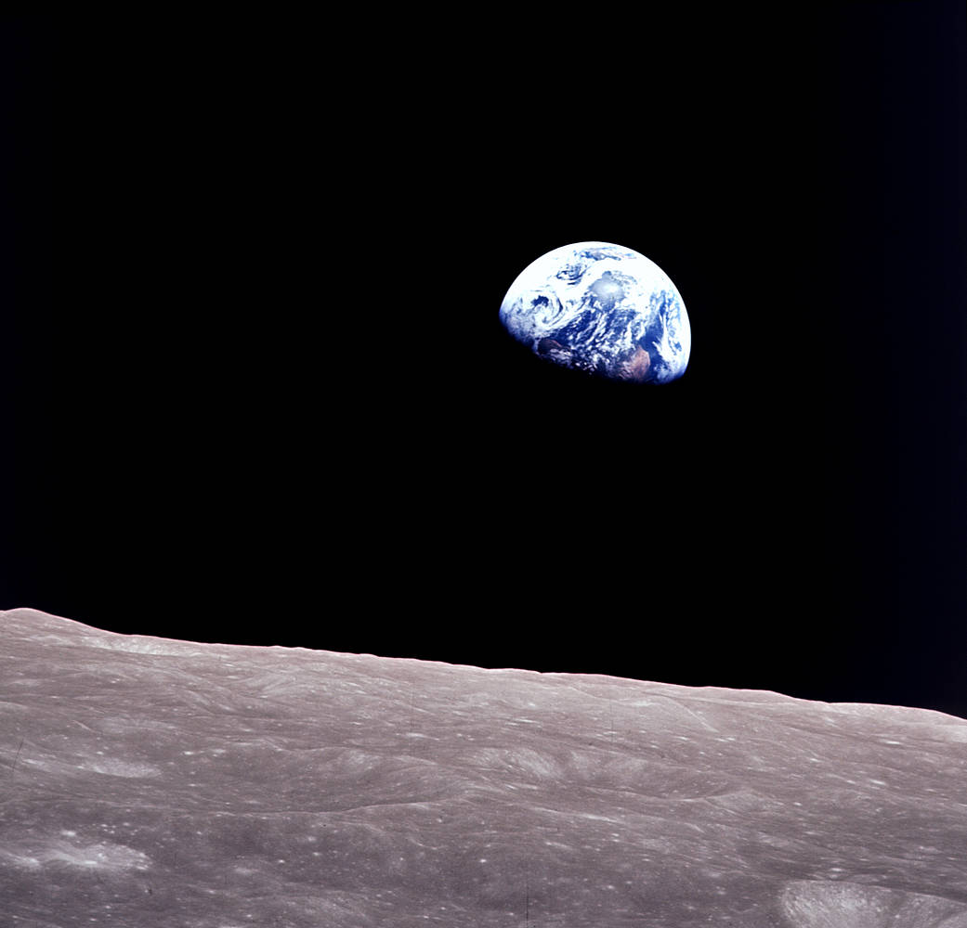 Photo credit: NASA
With photographs taken, scientific experiments completed, and televised broadcast ended, the crew began preparing for Trans-Earth insertion, which required the ignition of their service module rocket at precisely 89:19 elapsed mission time. Right on schedule, the engine fired and upon completion of the burn, Apollo 8 began the long journey home.
Their trip home was uneventful, as Borman’s health continued to improve throughout the mission. However, one final first for humans was realized during re-entry. The crew of Apollo 8 broke the human speed record, traveling over 25,000 mph at the time of re-entering Earth’s atmosphere!
Splash down of Apollo 8 occurred 147 hours after lift-off. Apollo 8 paved the way for future lunar missions, proving the capability of the Saturn V rocket and the ability to successfully orbit the Moon. NASA boasts that the mission was 99.9 percent accurate and achieved all mission goals.
Of the three Apollo 8 crew members, only Jim Lovell traversed the heavens again (Apollo 13). Frank Borman eventually became the CEO of Eastern Airlines, and Bill Anders enjoyed a two-year stint as U.S. Ambassador to Norway (1976-1977).

Jim Lovell’s thoughts on Apollo 8:
“Well Frank, my thoughts are very similar. The vast loneliness up here at the Moon is awe-inspiring, and it makes you realize what you have back there on Earth. The Earth from here is a grand oasis in the big vastness of space.”
Bill Anders’ thoughts of the Lunar surface”
“Looks like a sand pile my kids have been playing in for a long time-it’s all beat up-no definition-just a lot of bumps and holes.”

References and further reading:
Apollo 8 Flight Journal - Day 2: The Green Team (nasa.gov)
The Story Behind Apollo 8's Famous Earthrise Photo | NASA Solar System Exploration
The Flight of Apollo 8 - Moon: NASA Science
Apollo 8 (AS-503) | National Air and Space Museum (si.edu)
Apollo 7 (AS-205) | National Air and Space Museum (si.edu)

The term “rookie” denotes an astronaut’s first space mission. However, I must note that the number of training hours NASA required for their Apollo astronauts prior to any mission would make one a semi-pro at the least! Also note: While Apollo 8 did not have a Lunar Module (LEM), it was equipped with an equivalent mass (9027kg).
Virgil “Gus” Grissom (many believed he would be tagged to be the first man on the Moon), Edward H. White II, Roger B. Chafee.
Apollo missions 4 and 6 were unmanned test flights of the Saturn V.
I use quotation marks for secretly and privately, because just how secret or private can one be in such close quarters?
It is possible that Frank Borman was suffering from “Space Sickness” (similar to motion sickness), however very few astronauts cared to admit to the feeling of nausea or sickness during a space mission for fear of losing future missions or possibly out of fear of being a lesser astronaut.

